The Northern California Indian
Development Council, Inc.

The Northern California Indian Development Council, Inc.

241 F Street
Eureka, CA
95501
(707) 445-8451
www.ncidc.org
To download or print more copies, visit:
www.ncidc.org/community-health-wellness/nutrition



Children's Holiday Recipe Cookbook
Tools for cooking:

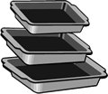
Baking Pan- Square or rectangle pan used for baking and cooking in the oven (Metal or Glass).
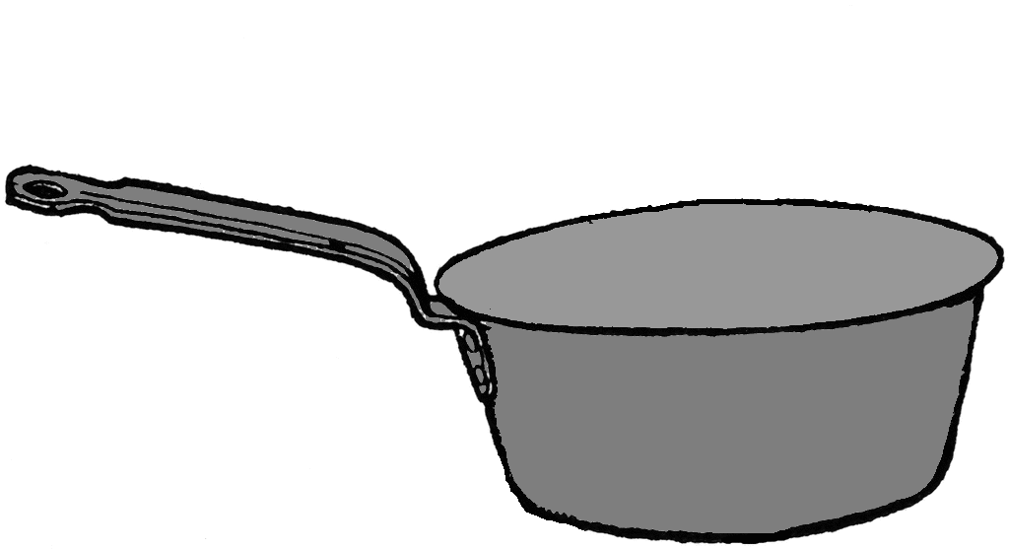

Sauce Pan- Deep pan with a handle used for
stovetop cooking.

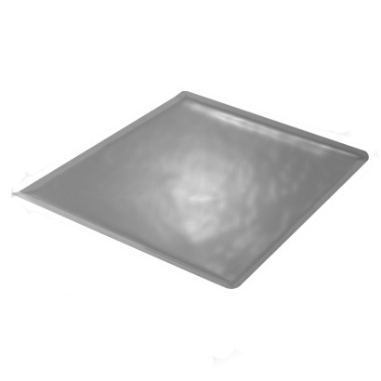

Mixing Bowls- Different sized bowls used for mixing ingredients together (Metal, plastic, glass, ceramic, wood).

Cookie Sheet- Flat metal sheet used for baking.
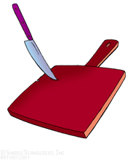

Cutting Board- Wooden or plastic board used
when cutting or chopping ingredients.


Teaspoons/Tablespoons- Different sized
spoons used to measure ingredients.
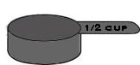

Measuring cups- Plastic cups with specific measurements used to measure non-liquid items.

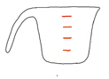
Glass Measuring Cups- Glass cup with measurements
along the side, used to measure liquid items.

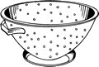
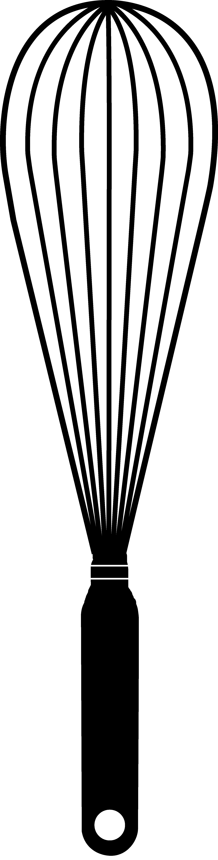
Colander- Bowl with holes in it used to drain liquids from foods.

Whisk- Non-electric hand held utensil used to
mix and stir ingredients together.
Jell-O Squares

Ingredients:
9 ounces jello (gelatin any flavor)
3 cups boiling water
1 ounces unflavored gelatin
12 ounces cool whip

Directions:
1. Mix gelatin and jello together in a mixing bowl. Add boiling water. Stir until jello is dissolved.
2. Add Cool Whip, stirring until melted.
3. Pour into a 13 x 9 glass baking pan.
4. Refrigerate several hours or until set.
5. Cut into squares.
6. Keep refrigerated until ready to eat.
______________________________________________________

Creamy Orange Salad

Ingredients:
6 ounces jello
16 ounces mandarin orange (sections)
8 ounces pineapple (crushed)
24 ounces fat free cottage cheese
12 ounces cool whip

Directions:
1. Drain pineapple and orange slices well.
2. Mix cottage cheese and jello powder in bowl and blend until smooth.
3. Remove from bowl and put into a large mixing bowl.
4. Fold in drained pineapple, then fold in cool whip, then 3/4 orange slices.
5. Transfer to large serving bowl. Arrange remaining slices on top.
6. Refrigerate for 4 hours.

Mashed Potatoes
Substitutions:
For every 1 cup of butter substitute with 1 cup of margarine OR 1 cup shortening plus 1/2 teaspoon salt.

For every 1/2 cup of milk substitute with 1/2 cup of water.

Ingredients:
6 potatoes (peeled and cubed)
1/2 cup milk (warm)
1/4 cup butter (margarine)
3/4 teaspoon salt
1 dash pepper

Directions:
1. Put potatoes in a saucepan and cover with water.
2. Cover the top of the saucepan and bring to a boil; cook for 20-25 minutes or until potatoes are very soft.
3. Drain water. Add milk, butter, salt and pepper; mash until light and fluffy.
________________________________________________________________________
Substitutions:
Substitute chicken bouillon with chicken stock or broth or even just water.

For every 1 cup of butter substitute with 1 cup of margarine OR 1 cup shortening plus 1/2 teaspoon salt.

For every 1 cup of cream cheese substitute with 1 cup pureed cottage cheese.

For every 1 cup of sour cream substitute with 1 cup plain yogurt.
Slow Cooker Mashed Potatoes

Ingredients:
5 lbs potatoes
1 Tablespoon minced garlic
3 cubes chicken bouillon
8 ounces sour cream
8 ounces cream cheese
1/2 cup butter
salt
pepper

Directions:
1. In a large pot of lightly salted boiling water, cook the potatoes, garlic, and bouillon for 15 minutes. Drain water into a bowl, saving the water. In a mixing bowl, mash potatoes with sour cream and cream cheese, adding the saved water as needed.
2. Move the potato mixture to a slow cooker, cover, and cook on low for 2 to 3 hours. Just before serving, stir in butter and season with salt and pepper.
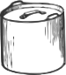
Cooking Pot- Deep pot used for cooking soups and whole chickens.

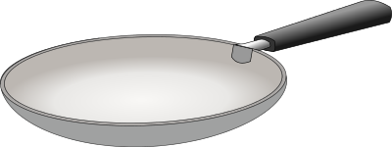
Skillet- Flat low-sided pan used for frying and sautéing food in hot oil or fat.

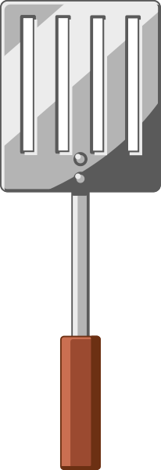

Spatula (cooking)- Flat metal or plastic utensil
used to lift, turn, and flip foods.

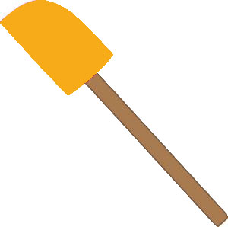
Spatula (baking)- Flat rubber or silicone head used to mix wet ingredients and to scrape the sides of
bowls in baking.



Oven Mitts- Thick fabric shaped as a mitten used to hold hot pans, baking sheets, plates, and pots.

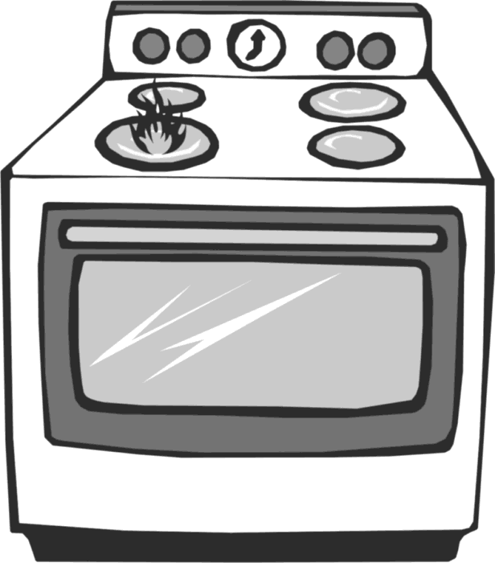
Oven- Refers to the inside where food is
baked for long periods of time.

Stove- Refers to the burners: either coils or
gas flames used for cooking in pots and pans.

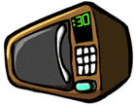
Microwave- Machine used to heat and cook different types of foods.

Terms:

_____________________________________________________
Measurements:
Teaspoon: tsp. or t.
Tablespoon: Tbsp. or tbsp. or T.
Cup: C. or c.
Ounce: oz. or OZ.
Pound: lb. or LB.
Baked Ham with Pineapple
Cream: to mix ingredients together until they are smooth and creamy.

Dice: to cut food into evenly cut small squares.

Drain: to pour out liquid in which the food has been cooking or stored in.

Drizzle: to sprinkle drops of liquid lightly over the top of desired food.

Fold: to gently combine ingredients together until they are mixed together.

Grate: to shred food into small pieces with a shredder or grater.

Mince: to cut or chop into very small pieces.

Score: to make diagonal cuts in the food using a knife.

Spoon: to gently pour the food from the spoon onto the desired food.
Bake: to cook inside the oven.

Baste: to pour juices or melted fat over food while cooking.

Beat: to mix fast with a spoon, fork, whisk, or electric mixer.

Blend: to mix foods together until smooth, or mix in electric blender.

Boil: to cook a liquid until bubbles appear.

Broil: to put food underneath the broiler part of the oven.

Brown: to cook food until the food turns brown.

Chill: to place food in refrigerator until it is cold.

Chop: to cut food into small pieces.

Cool: to let food sit at room temperature until it is no longer hot.

Substitutions:
For every 1 Tablespoon of cornstarch substitute for 2 Tablespoons all purpose flour.

For every Tablespoon of prepared mustard substitute with 1 teaspoon dried mustard.

For every 1/2 cup of brown sugar substitute with 1/2 of white sugar.
Ingredients:
3 lb. canned ham
8 ounces pineapple crushed
1 Tablespoon cornstarch
1/2 cup brown sugar
1 Tablespoon lemon juice
2 teaspoons dry mustard

Directions:
1. Score ham. Microwave 20 minutes. Drain any liquids.
2. Blend glaze ingredients in a microwave safe dish. Microwave for 4 minutes or until mixture thickens and looks clear.
3. Spoon over the ham, keeping the pineapple on top.
4. Cook ham on broil about 5 minutes, basting twice.
5. Let stand covered for 10 minutes.
______________________________________________________

Ham and Cheese Mini Frittatas
Substitutions:
For every 1 cup of shredded cheddar cheese substitute with 1 cup of any type of shredded cheese.

For every 1/4 lb. cubed fully lean ham substitute with non-lean ham.

For every egg substitute with 2 Tablespoons water, 2 Tablespoons flour, 1/2 Tablespoon shortening, and 1/2 teaspoon baking powder.
Ingredients:
1/4 lb. cubed fully lean ham
1 cup shredded cheddar cheese
6 eggs
4 egg whites
3 Tablespoons minced chives
2 Tablespoons 2% milk
1/4 teaspoon salt
1/4 teaspoon pepper

Directions:
1. Spray muffin pan with cooking spray. Divide ham evenly among 8 muffin cups; top with cheese.
2. In a large bowl, beat eggs and whites. Beat in chives, milk, salt, and pepper. Pour over cheese, filling cups three fourths full.
3. Bake at 375 F for 25 minutes or until a knife inserted near the center comes out clean. Carefully run a knife around edges; remove from pan. Serve warm.

